**DOKUZ EYLUL UNIVERSITY**

**ENGINEERING FACULTY**

**DEPARTMENT OF COMPUTER ENGINEERING**

**CME1252 PROJECT BASED LEARNING – II**

**FINAL REPORT**

**PROJECT – I**

# CAR RENTAL SYSTEM

**by**

**Sıla Idil MURAT**

**Alptuğ TOPALHAN**

**Cemil DALAR**

**Lecturers**

**Prof.Dr. Mehmet Hilal OZCANHAN**

**Res.Asst. Elife OZTURK**

**IZMIR**

**16.04.2021**

# CHAPTER ONE

PROGRESS DESCRIPTION

The project started on 15.03.2021. The scope of the project was determined and coding was started.

First of all , an outline was determined on how to proceed during the project. Attributes , constructor , class , methods and solution alternatives that will be needed in the project was determined. The project started by creating classes, for employee, office and car. Add and list commands have created for employee , office and car. Then, reading from file and taking input from user have made.Customer class has created and delete command have added for office and employee.

Add and list commands have generated for carRequest. Making contracts and error messages were made. Nextday operations that are office profits , statistics and system recommendations have shown on the console.

# CHAPTER TWO

TASK SUMMARY

## Completed Tasks

Sıla İdil Murat; System recommendations , delete command for employee and office have completed.

Alptuğ Topalhan: Office class ,customer class ,car class and employee class were created. Getting input from user was completed. The method and functions of the

clasess were created. Nextday operations such as office profits and statistics has been completed.

Cemil Dalar:Date class,carrequest class and contract class were created. Their attributes, constructor and methods were created. Creating a contract were made.

Addcarrequestrandom and addcarrequestnrandom methods were created.

## Incomplete Tasks: Reasons and Explanations

Sıla İdil Murat: There are no incompleted tasks in the project.

Altuğ Topalhan:There are no incompleted tasks in the project.

Cemil Dalar:There are no incompleted tasks in the project.

## Additional Improvements ~~to the Project~~

Sıla İdil Murat: Shifting method is used to delete method.

Alptuğ Topalhan: Understandable codes with comment lines and meaningful variables were used in the project.

Cemil Dalar: He was able to comfortably give error messages by creating many boolean variables and processing them.

# CHAPTER THREE

EXPLANATION of algorıthms

## Screenshots

**

**

**

## Functions

addOfficeformain(String element1,String element2,String element3)

listofficeformain()

addemployeeformain(String element1,String element2,String element3,String element4,String element5,boolean emp_available)

listemployeeformain

addcarformain(String element1,String element2,String element3,String element4,String element5,boolean car_available)

listcarformain

addcustomerformain(String element1,String element2)

listcustomerformain

deleteOffice

deleteEmployeeformain(int element1,int element2)

addCarrequest(String [] arr1, Date start_date)

createContract(CarRequest carRequest, Date startday)

compareForRecommendation()

listCarrequest()

listContract()

addCarRequestRandom(String [] user_arr,Date startday)

addCarRequestNRandom(String [] user_arr,Date startday)

addRecommendationForCar(int count_car)

compareCarClass()

addRecommendationForEmployee(int count_employee)

getStatistics()

ndOffice()

getIncomes()

isSameday(Date date1, Date date2)

getChecker(int day1, int month1, int year1,int day2, int month2, int year2)

## Algorithms and Solution Strategies

Sıla İdil Murat: The add/list commands are created for employee, office, customer and car. Reading txt file and taking input from user part are completed. Then, add/list

For car request and delete commands have created. Random car requests , making contract and error messages have done. Nextday operations that are Office profits, statistics and system recommendations have made.

Alptuğ Topalhan; Classes were created and connections were established between some classes. Arrays of type employee and car class were created under the office class. In this way, it was possible to reach other classes by reaching a class with get and set methods. In order to receive commands from txt and user, split () function was used and assigned to an array. The first element of the array was checked in switch case. While adding employee and car, office ids were found with for loop and if. When it entered the ifs, operations were started. Shifting method is used when deleting elements from employee and office arrays. For system recommendations, counters were kept in some obcet types such as contracts, carrequests, and those were given as recommendations according to the counters. The availability of cars, workers, contracts was checked. Assign with boolean variables. Changes were made with setters at the end of the day for employees and at the end of the contract for cars and contracts. Dates received as input have been checked. On Nextday operations, employees could only get bonuses if it was the first day of the contract. The elements of the arrays such as the car worker present in the random or star inputs in the requests were selected using random indexes.

Cemil Dalar; First, researches were made about object oriented programming. And in line with this, classes, attributes and constructors were created. Later, algorithms that would work for us started to be created. Necessary methods were created for car requests and converting them into contracts. By using Boolean variables, the contract was made easily and error messages were given easily. Methods related to random car request have been made and these are sent to the createcontract method we have made before. And traded from here. Before signing the contract, each object was checked. According to the accessibility of the objects, checks were made with ifcommands. Then, if all boolean values ​​are correct, the contract is made. Employee and car accessibility values ​​are false. If the contract cannot be made, error messages will be given according to which boolean value or values ​​are incorrect.

# CHAPTER FOUR

PROBLEMS ENCOUNTERED

Sıla İdil Murat: When giving system recommendations to user counters are used in the main to evaluate best options for offices. But it did not work properly. Therefore, this counters assigned office class as attribute. Then counters have calculated and compare to give best option for recommendation.

Alptuğ Topalhan; While reading txt, utf8 error was encountered. The first line could not be split due to a special mark placed on the first line of the txt. The problem was resolved when the contents of the downloaded txt were copied and a new txt was created. When an array of type Employee is opened into the office class, each assignment has only one value and the other values become null. This was due to the fact that the width of the array was initially given when assigning the array. The problem is resolved when the width of the array is assigned within the consturactor. While deleting the element, array indexes shifted, there was a problem because the parameter that came into the functions of the commands was array index. The problem is solved when classes' own ids are used instead of the array index. The class ids were searched and found using for and if. While the nextday transactions were carried out, the workers in the profit part were receiving the bonus from the car sales every day. To solve this problem, the days of the contract were checked, if the contract was on the first day, it was checked to receive a bonus. When the contracts expired and new contracts were created, they were assigned to the same series, so the same cars were rewritten while writing the statistics. This problem was solved by checking the ids of the elements in the array.

Cemil Dalar; While contracting, I could not find the available vehicle objects.

Because in the wrong place I am making the variables car_available false. Later, I noticed this error, and after the contract was made, when the car_available was false, our code started working stably and correctly.

# CHAPTER FIVE

conclusıon

Using of some new methods , alternative and more effective solutions and the importance of teamwork were learned .It was very important to understand Object

Oriented subject and to use it properly in the project. The importance time management has been experienced in this project.

As a result , this project has contributed to us to learn Object Oriented programming better and to improve ourselves in java language.

REFERENCES

<https://www.javatpoint.com/object-and-class-in-java>

<https://stackoverflow.com/questions/7970857/java-shifting-elements-in-an-array>

https://docs.oracle.com/javase/tutorial\

**AppendIx A**

Poster/Web page of the Project

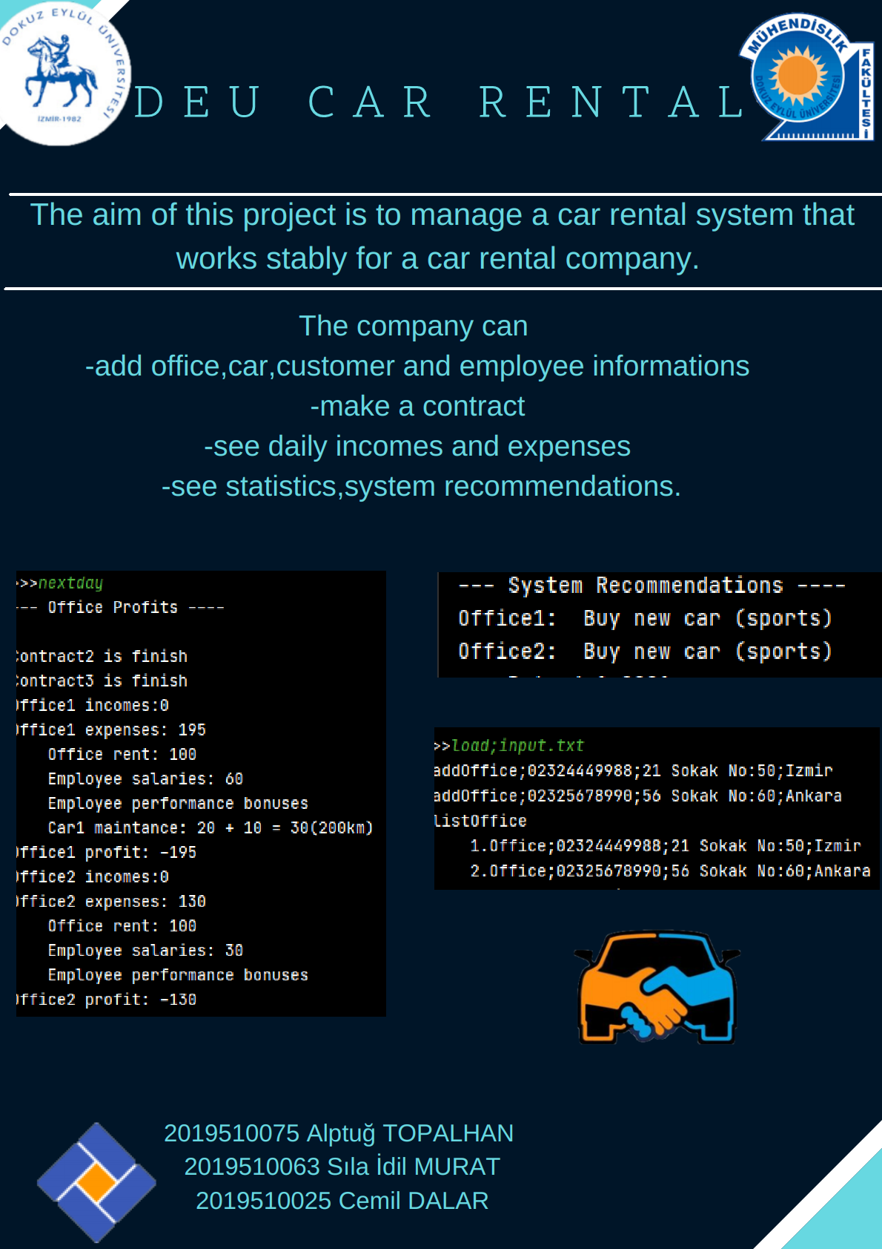

**AppendIx B**

Code of the Project

A method from our code

public static void deleteOffice(int off_id){  
 for(int i=**0;**i<*add_offarr1*.length**;**i++){  
 if(*add_offarr1*[i] !=null){  
 if(*add_offarr1*[i].getOff_id()==off_id){  
 for(int j=i+**1;**j<*add_offarr1*.length-**1;**j++){  
 *add_offarr1*[j-**1**]=*add_offarr1*[j]**;** }  
 *addoffstarter*=*addoffstarter*-**1;** }  
 }  
 }  
}  
public static void deleteEmployeeformain(int element1**,**int element2) {  
 for(int i=**0;**i<*add_offarr1*.length**;**i++) {  
 if(*add_offarr1*[i] !=null){  
 if(*add_offarr1*[i].getOff_id()==element1){  
 *add_offarr1*[i].deleteEmployee(element2)**;**break**;**}  
 }  
 }  
}